CS403/503 Programming Languages
Spring 2025
Assignment #4

- Write a program in C that uses the qsort function to sort an array of real numbers (double). Make sure your program works with real numbers that differ very small. Paste below only the comparison function passed to qsort as a parameter.
Answer:
int compare (const void *a, const void *b) {
return (*(double *)a - *(double *)b);
}

- Problem #5 of Chapter 9 on Page 413.
Answer:
- Passed by value
  - value = 2, list = {1, 3, 5, 7, 9}
  - value = 2, list = {1, 3, 5, 7, 9}
  - value = 2, list = {1, 3, 5, 7, 9}

- Passed by reference
  - value = 1, list = {2, 3, 5, 7, 9}
  - value = 1, list = {3, 2, 5, 7, 9}
  - value = 2, list = {3, 1, 5, 7, 9}

- Passed by value-result
  - value = 1, list = {2, 3, 5, 7, 9}
  - value = 1, list = {3, 2, 5, 7, 9}
  - value = 2, list = {3, 1, 5, 7, 9}

- Programming Exercise #8 of Chapter 9 on Page 415.
Answer:
a4_3.h
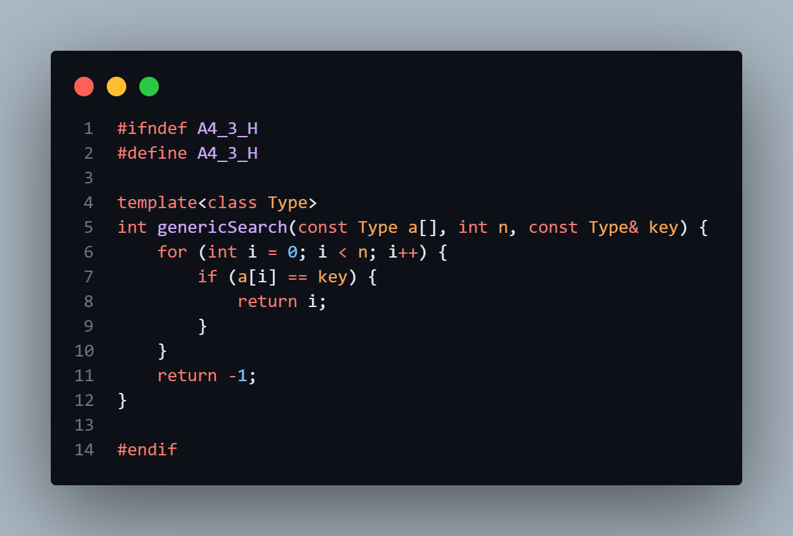
a4_3.cpp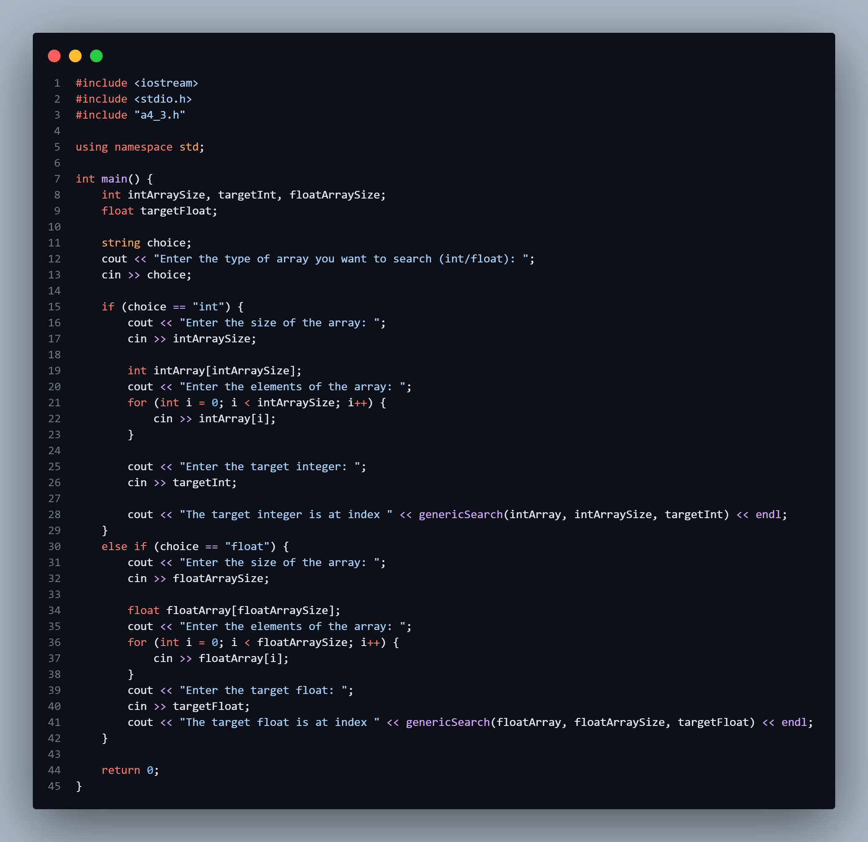

- Problem #3 of Chapter 10 on Page 443 (See Figure 10.9 on page 433 for how to draw a stack).
Answer:

ARI D | dynamic link
 | static link
 | return (to C)
ARI C | dynamic link
 | static link
 | return (to A)
ARI A | parameter (flag = False)
 | dynamic link
 | static link
 | return (to B)
ARI B | dynamic link
 | static link
 | return (to A)
ARI A | parameter (flag = True)
 | dynamic link
 | static link
 | return (to BIGSUB)
ARI BIGSUB | dynamic link
 | static link
 | return (to caller)

